**PROGRAM 1:**

**OUTPUT:**

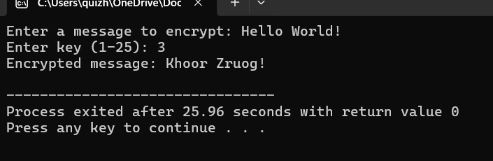

**PROGRAM 2:**

**OUTPUT:**

**PROGRAM 3:**

**OUTPUT:**

**PROGRAM 4:**

**OUTPUT:**

**PROGRAM 5:**

**OUTPUT:**

**PROGRAM 6:**

**OUTPUT:**

**PROGRAM 7:**

**OUTPUT:**

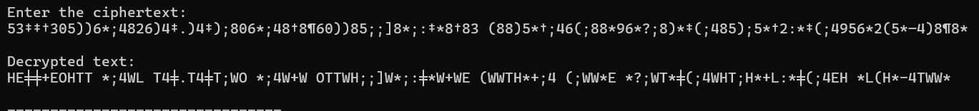

**PROGRAM 8:**

**OUTPUT:**

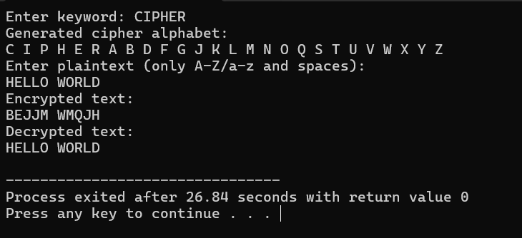

**PROGRAM 9:**

**OUTPUT:**

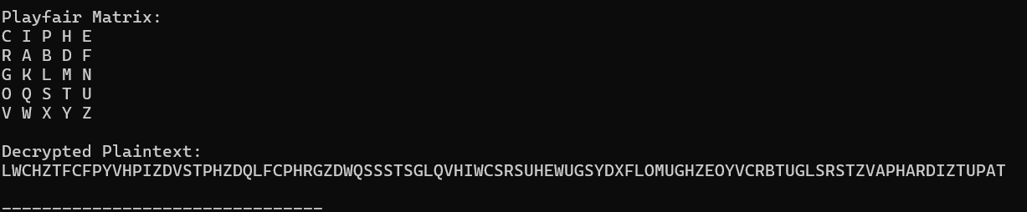

**PROGRAM 10:**

**OUTPUT:**

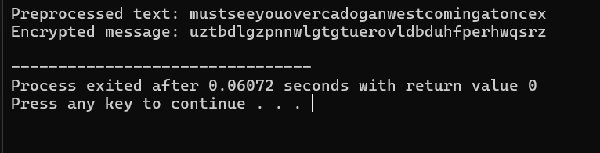

PROGRAM 11:

OUTPUT:

**PROGRAM 12:**

**OUTPUT:  
**

**PROGRAM 13:**

**OUTPUT:  
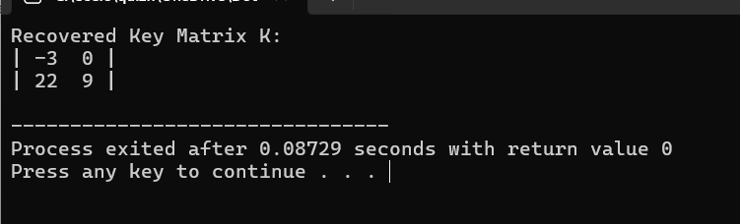**

**PROGRAM 14:**

**OUTPUT:**

**PROGRAM 15:**

**OUTPUT:**

**PROGRAM 16:**

**OUTPUT:**

**PROGRAM 17:**

**OUTPUT:**

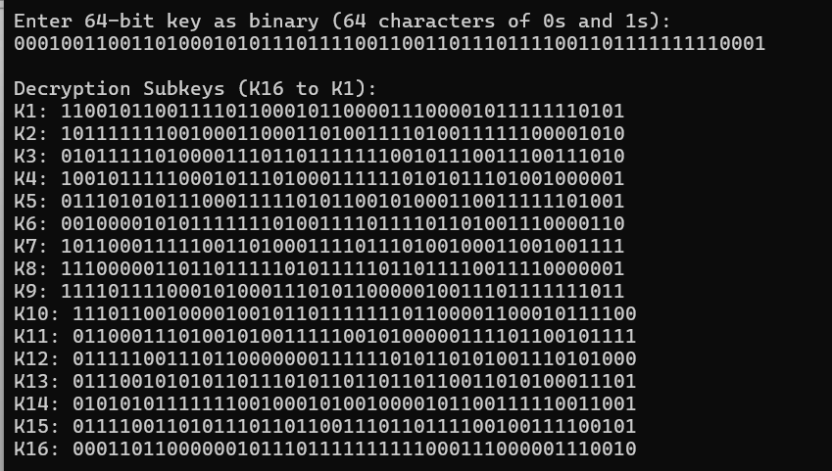

**PROGRAM 18:**

OUTPUT:

**PROGRAM 19:**

**OUTPUT:**

**PROGRAM 20:**

**OUTPUT:**

**PROGRAM 21:**

**OUTPUT:**

PROGRAM 22:

OUTPUT:

**PROGRAM 23:**

**OUTPUT:**

**PROGRAM 24:**

**OUTPUT:**

**PROGRAM 25:**

**OUTPUT:**

